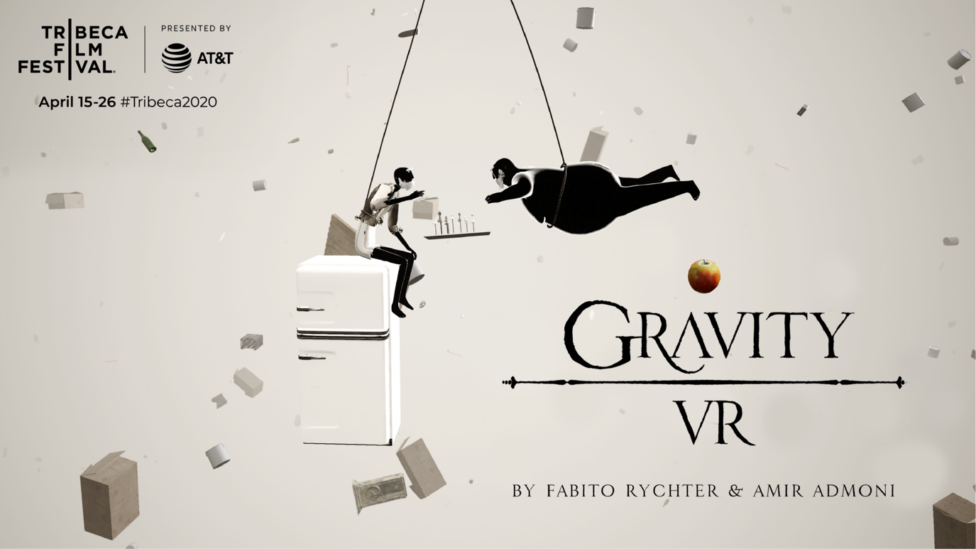

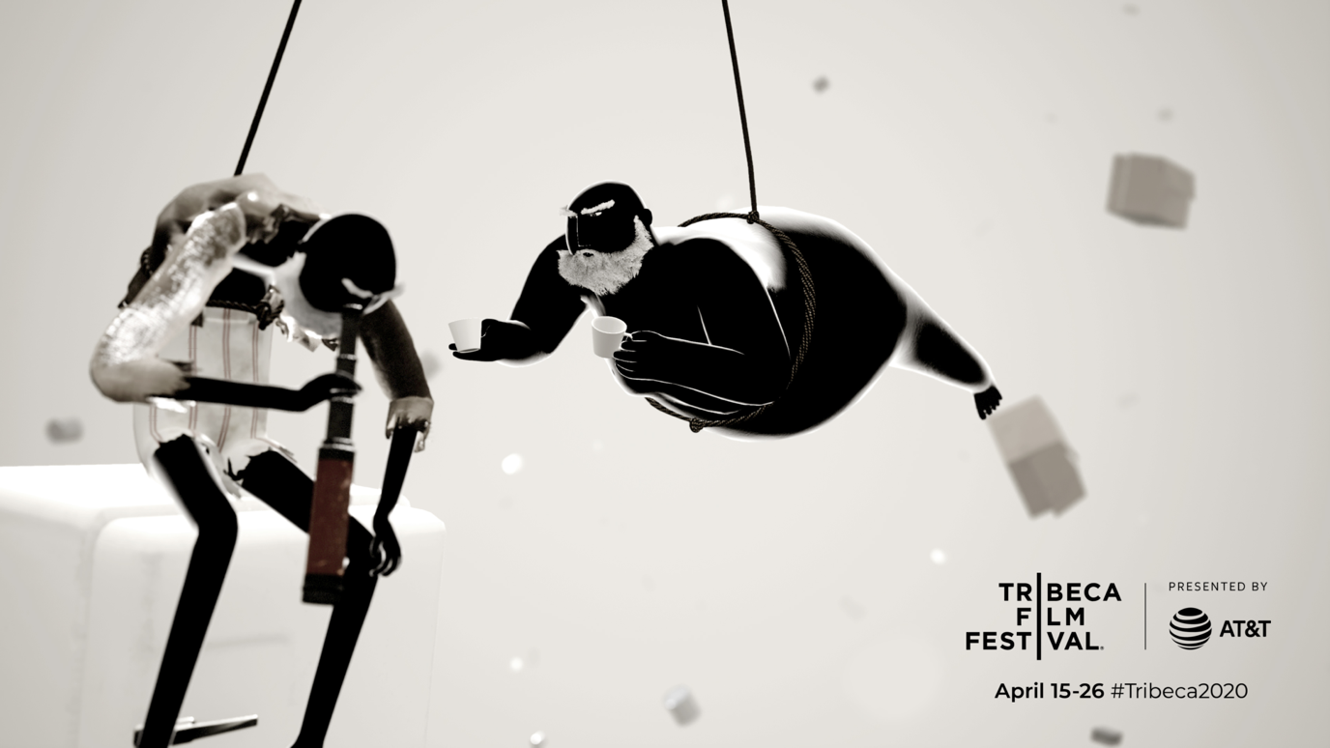

GRAVITY VR

Duration: 16 min

Hardware required: Oculus Rift / HTC Vive

Credits:

Written and Directed by Fabito Rychter & Amir Admoni
Lead Programming: Owen Svelmoe
Narrator: Peter Baker (english), Mauro Rychter (portuguese)
Art Direction: Amir Admoni
Mocap: Fabio Rychter
Hair and Grooming: Jeniffer Blômeke
Rigging: Adeel Afzal, Daniel Bim
Character Modeling: Natan Zuanaci
Music and sound effects: Fabio Rychter
Main contributions: Murilo Camargo Pereira, Daniel Sasso, Marco Antonio Salas Castañeda, Luis Guillermo Butron Quispe

Long synopsis:

Gravity VR takes place in a surreal world with no ground beneath your feet. Everything that exists is forever falling. Houses, clothes, cars... Everything just falls. And the player too. But there is no vertigo or fear. The feeling is like floating in zero gravity.

At this place you meet two old brothers living a surprisingly ordinary life. Seems like nothing in this chaotic world would disturb their lonely and slow routine. Until one day...

Short synopsis:

In a surreal world with no ground beneath your feet, where everything is forever falling, you meet two old brother living a surprisingly ordinary life. But nothing lasts forever.

Short Bio:

Amir Admoni and Fabito Rychter have been working together for the last 10 years. The partnership yielded movies, TV shows and plays that have collected 71 international awards and travelled to more than 120 festivals. Gravity VR is their first virtual reality project together. But definitely not the last.

Contact Info:
Fabito Rychter
Email: fabitorychter@gmail.com
Whatsapp: +55 21 99971-0022

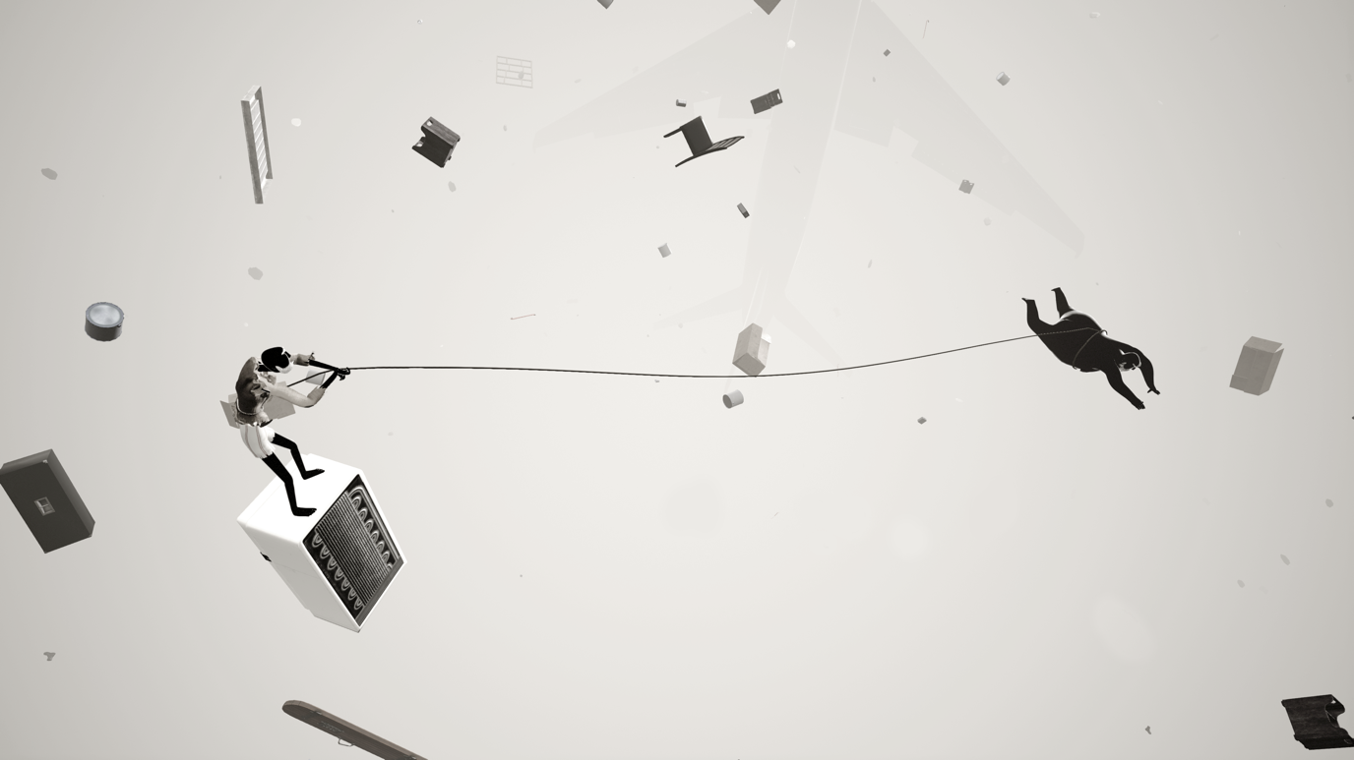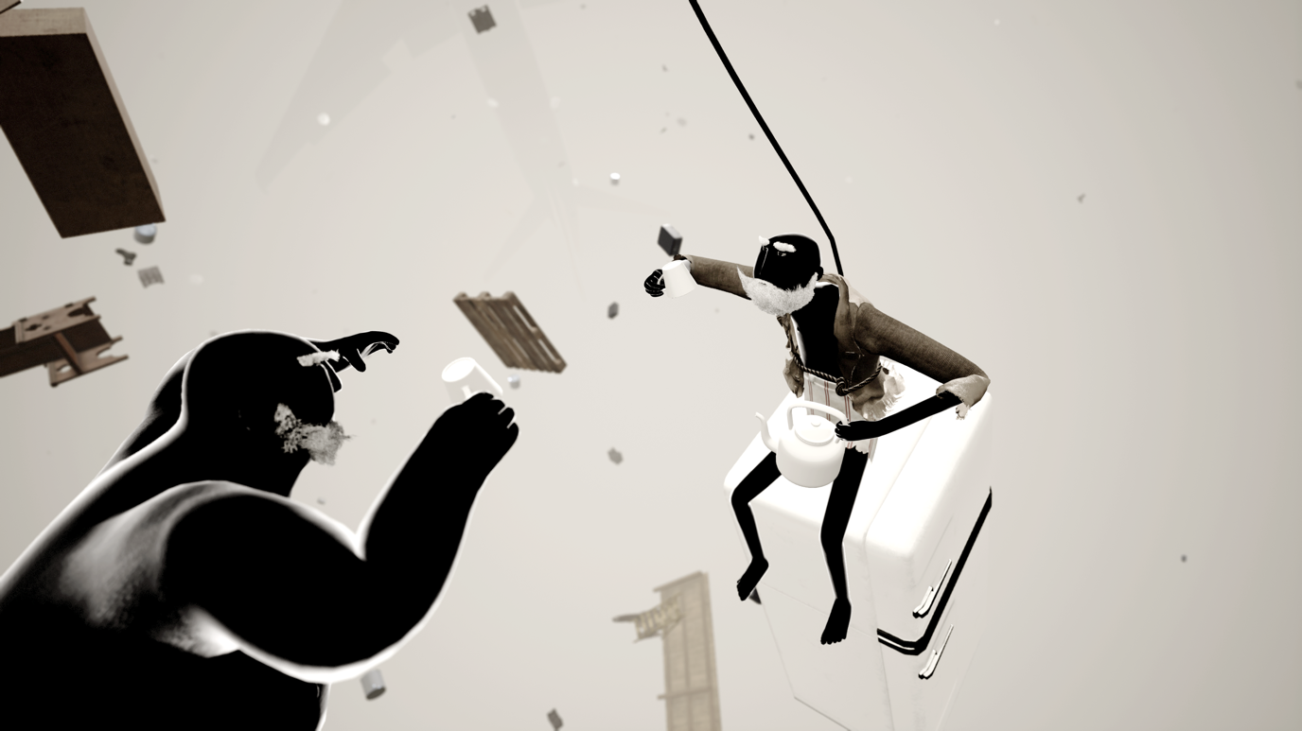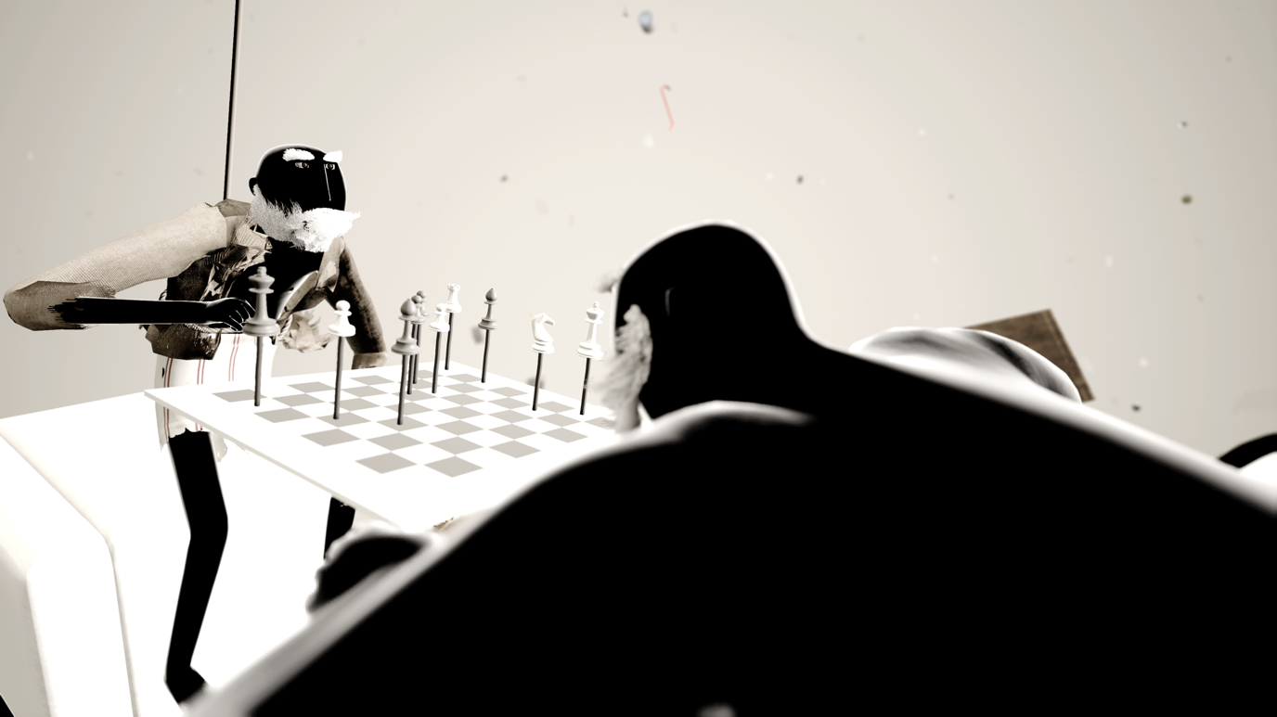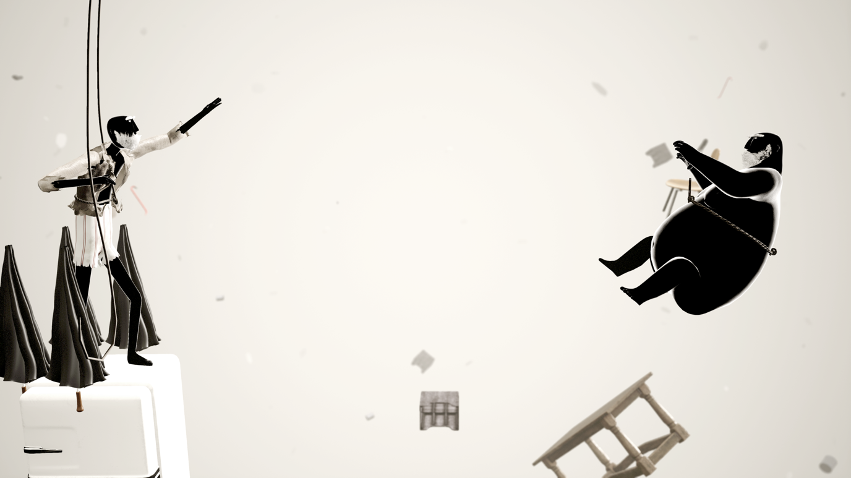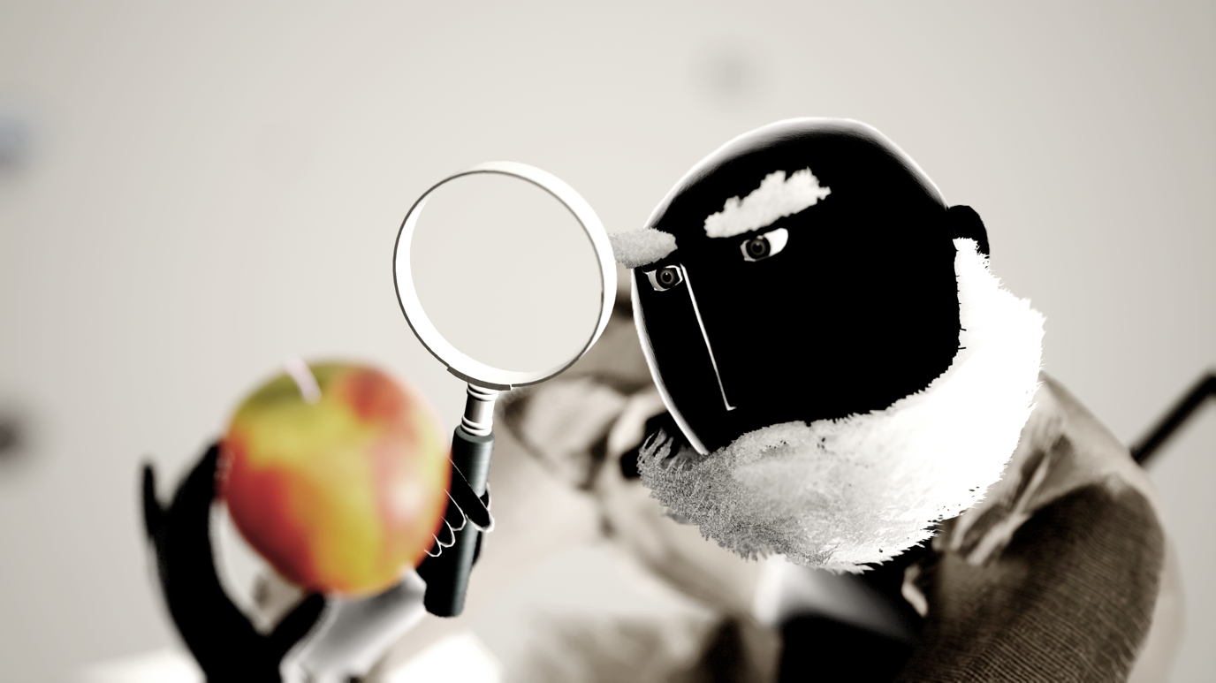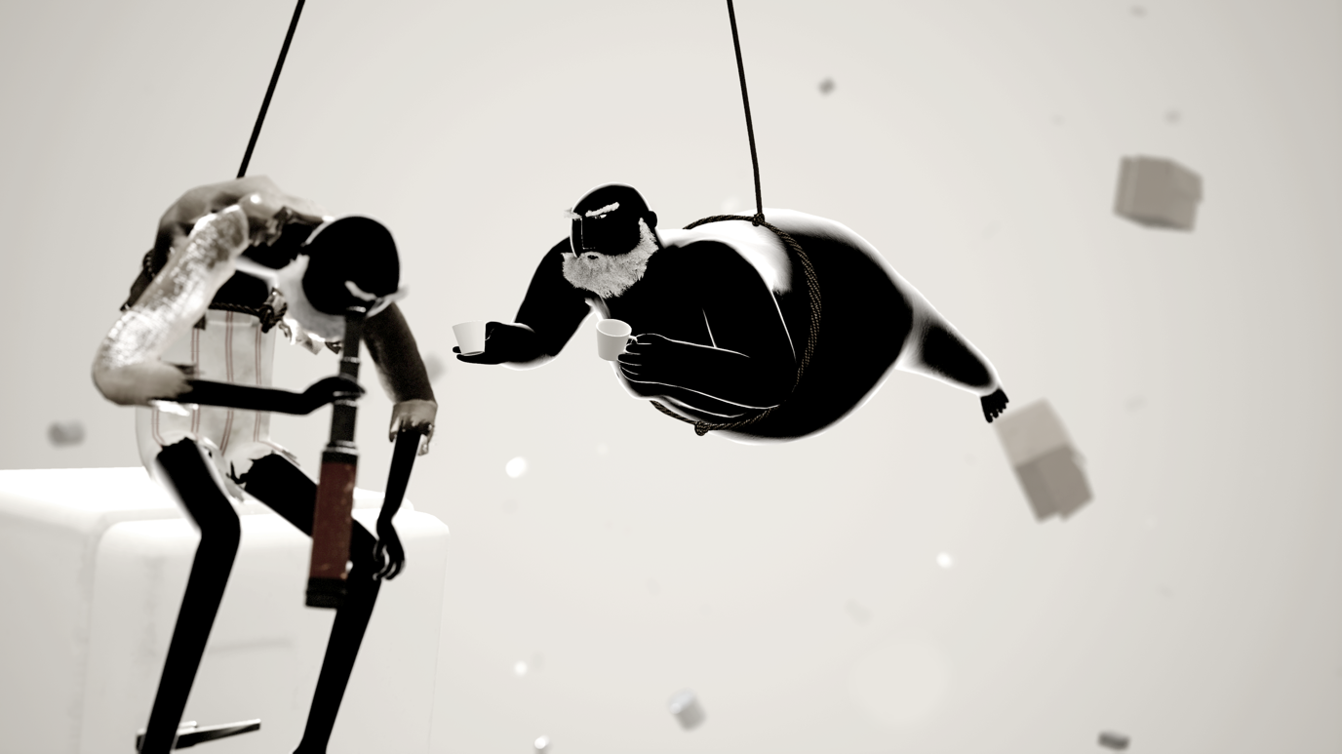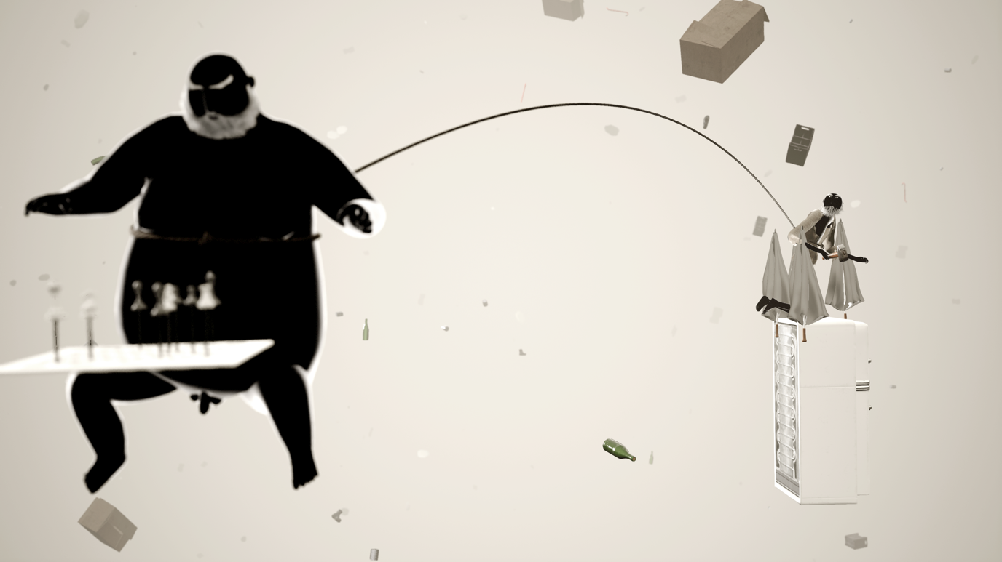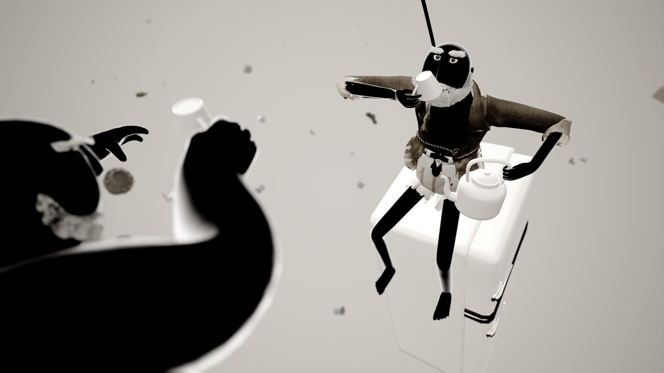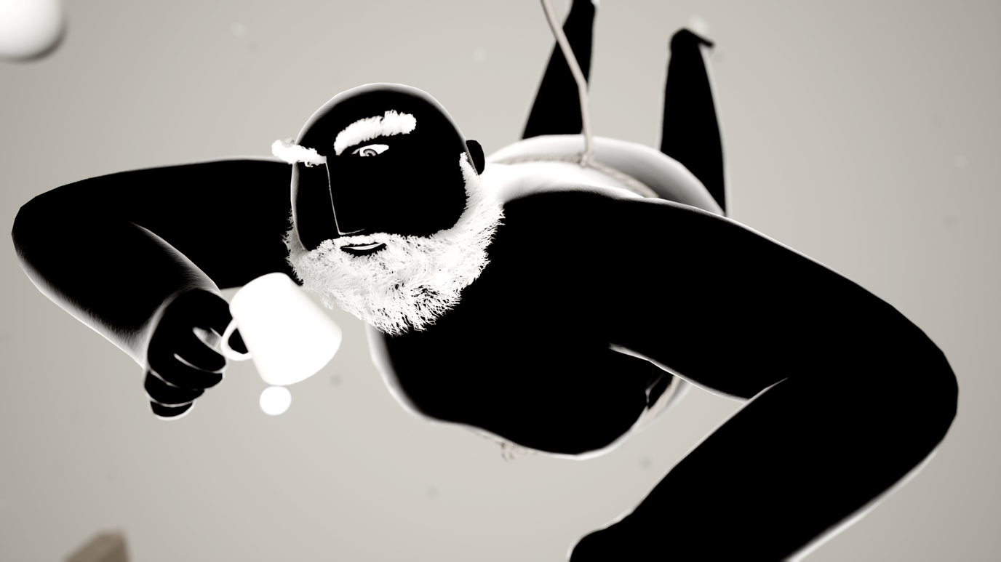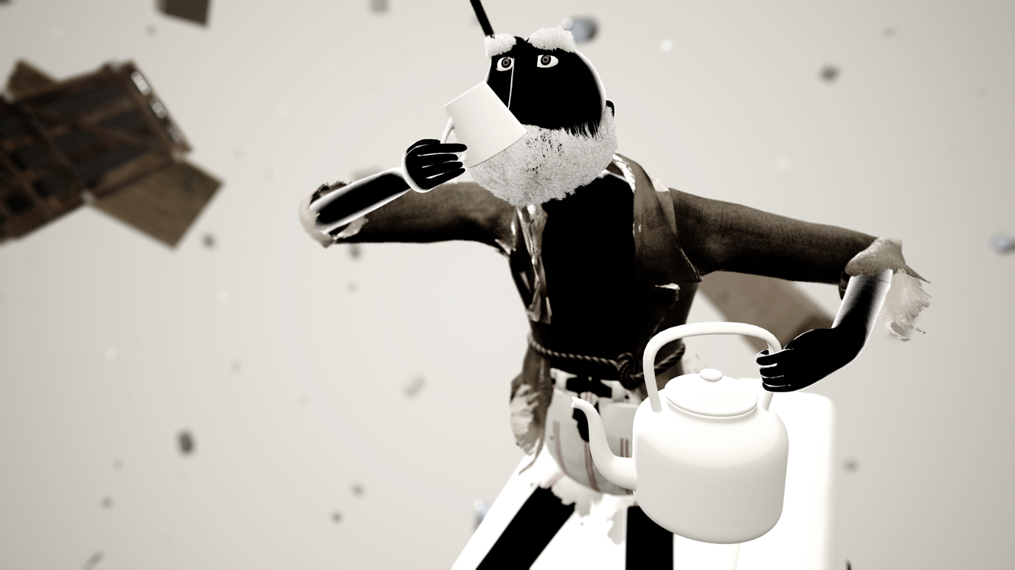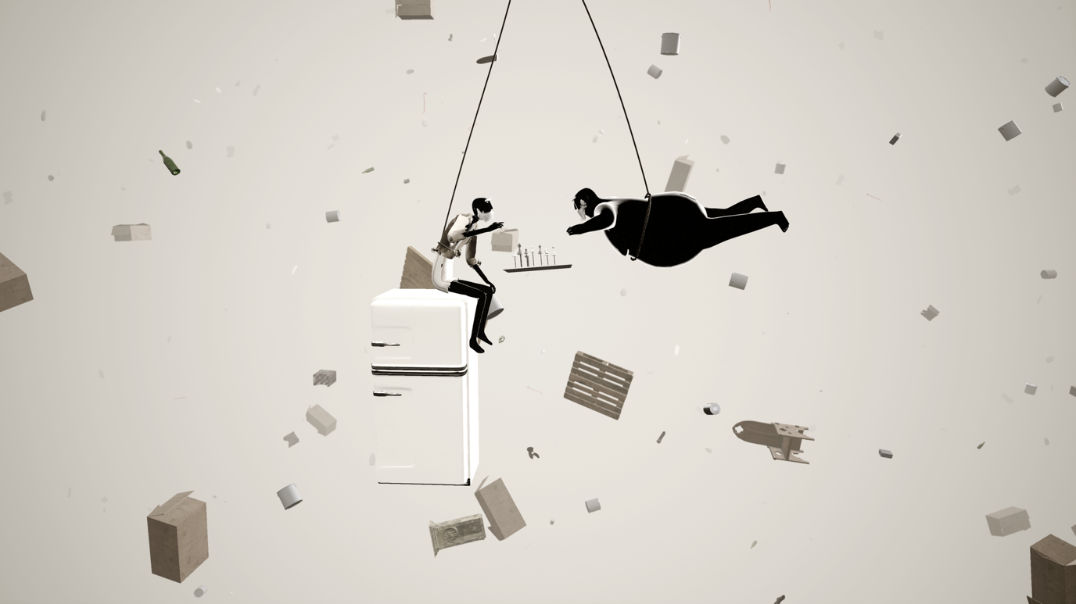

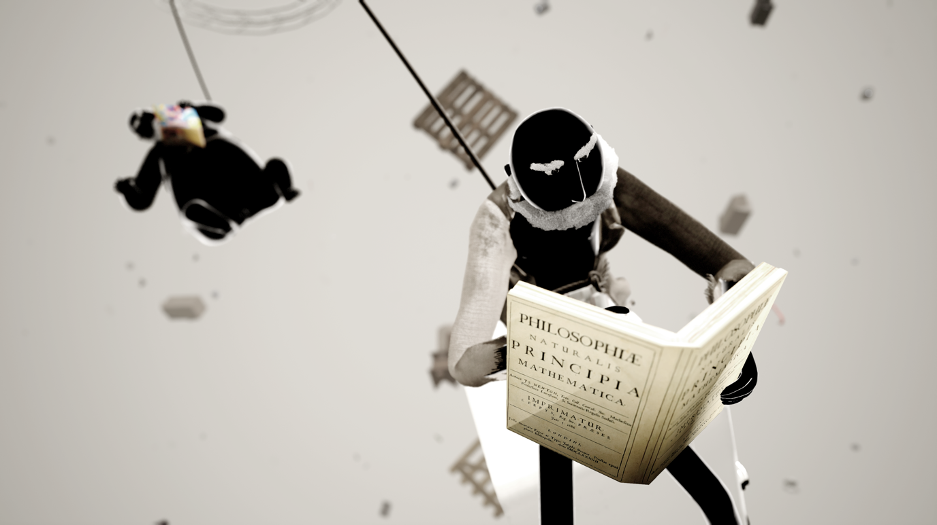

Q&A

What influenced this work?
It's hard to believe but it all started with an experience involving dinosaurs, a real jeep, some fans and a Rift DK2. The dinosaurs looked like they came from a 90's video game, the motion made me completely sick and the script and voice acting were as tacky as you imagine. But it was my first time in VR and I was completely blown away. I went 3 times in a row on this ride. After the second time I pre-ordered my first lenses. After the third time I quit my 15 year old script writing job at Brazil's biggest TV station. I just couldn't fight it, after that day I could only have ideas for VR experiences. Three months later I opened Delirium XR, my VR production company.
It's funny but I was also greatly influenced by VR's first tech demos. After walking the plank and meeting that whale face to face, it was clear to me that in VR you could provoke emotions and feelings that were impossible through any other medium.
Right at that time, when my mind was spitting a thousand VR ideas a second (mostly bad ideas), Amir and I were just finishing our short Gravity, a tradicional short that started it all.
The movie was all made in 3D so it was obvious that I would pitch transposing it to VR.
I can't know for sure when the idea for this story came out but I remember Amir (the other writer/director) talking about a never ending fall when we were writing our first short, Linear, back in 2012.
Amir has been on the jury of many animation festivals and has seen about everything, I bet that if it was him writing this answer, there would be mentions of many obscure movies and shorts that we've never heard about.
Gravity VR got funded 2 years after we first talked about transposing the short. By then I was mature enough as a VR producer to know that the tech-demo times of VR were over. We already had Dear Angelica, the shorts from Penrose, Atlas V and also games that raised the bar on what art and storytelling in VR could accomplish. I was certain that simply transposing the Gravity short to VR would never work. So we did what we felt had to be done: bit the bullet and started from scratch.

Storytelling brings communities together. Tell us how your film/project does this.
I still can't tell you how (or if) the Gravity VR experience will actually bring communities together. It seems like a bold claim for something still very "niche" as VR. But I can tell you how its production did.
I am a brazilian living in Lima but that's not what makes Gravity VR's country of origin hard to define.
The art was made in São Paulo, Brazil, the animations were recorded in Lima, Peru, programing was written in Las Vegas, rigging was done in Lahore, Pakistan, the beards were groomed in Kortrijk, Belgium and the narration was recorded in Stockport, UK
We all come from very different backgrounds and are spread apart by thousands of kilometers.
During production, none of the team members ever met in person. The whole experience was produced 100% remotely. Amir and I wrote and directed the experience living in different countries and only met on the day we first showed it publicly.

Why does this story need to be told now? Why is it relevant?
I think that the story touches important themes like polarization, lack of dialogue and irreconcilable differences. We follow two brothers that have been tied together their whole lives but even so develop completely different points of views about how things are at the present time, how things will be in the near future and what they should do about it.
They inhabit a chaotic world with so much noise that it becomes impossible to listen properly to what the other is trying to say. Without dialogue there's no exchange, no agreement, no middle ground. Both are firmly locked in their own views and that is enough to make living together unbearable.
I am sure this whole plot must seem fairly familiar to people in many countries right now.

Tell us what you're excited to experience at Tribeca 2020 or a favorite anecdote from a past Tribeca Film Festival.
This is the first time we are going to Tribeca, I have no idea what to expect. Our first short, Linear, travelled to about 120 festivals but nothing near as big as Tribeca. To be honest, when I got the invitation I thought someone was pranking me.
I've been following how the Tribeca Immersive is growing in size and importance and I confess it makes me a bit nervous. Standing beside the big names of the industry while they try your experience must be extremely nerve wrecking. And thank god there's no red carpet for VR experiences! The clothes people wear for these events probably cost more than the whole budget we had for our production.

What are some pertinent issues and experiences that you wish were represented with greater frequency on screen?
Although I understood the importance of movies that brought out issues related to prejudice, inequality and sustainability, some time ago I felt like these themes were being over explored.
But with the rise of the far right movement all over the world, I realize I was completely wrong. If that doesn't mean clearly that we actually need more of these movies, I don't know what does.
About VR experiences, what I feel is that most realtime rendered experiences I see, although very well made, seem geared towards kids and teenagers or are just very childish. I just wish I could find more great experiences that really aim at a more mature audience.

What innovative technologies or tools did you use to create this project, if applicable?
We created our own motion capture system that allowed us to record the animations straight in VR. The difference from traditional motion capture is that recording using VR lenses allowed us to be immersed in the story world, to interact with the other characters and see the final results right on the spot. It was simple and fast enough that I chose to write the script wearing the motion capture suit. That way I could record the scenes right after writing them and make changes straight away.

Are there any interesting stories you can share with us on how you funded your film/project?
The project got selected by a bank's art fund among 12.000 other projects (TV, theatre, music, arts...). The selection process took over a year. When we got the news we would get funded, technology and the VR medium had changed so much that little of what we had planned on the original project made any sense. So we changed everything.. When we delivered the finished product there was definitely some astonishment but fortunately everyone was surprisingly pleased.

Pitch your movie. Why should we care about it.
Gravity VR is a wild ride through a chaotic world. Follow the last moments of two old brothers while free falling for 15 minutes. An emotional and thrilling journey in a surreal universe with no ground beneath your feet. A parable, a fable, an interactive experience. In Tribeca, for improved immersion, you will have the opportunity to watch it floating on a hanging chair with fans
